How to generate the CLS file using Siemens NX

To generate the CLS file do the following:

- Be sure you are in the Manufacturing application

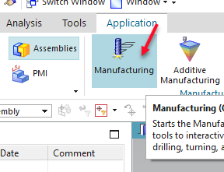

- Select the program or operation to output

- In the Home tab, Operations area, select More > Output CLSF

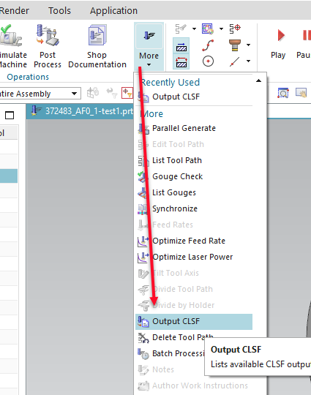

- The CLSF Output format should be set to CLSF_STANDARD!

